**Screen Shots**

1. Login

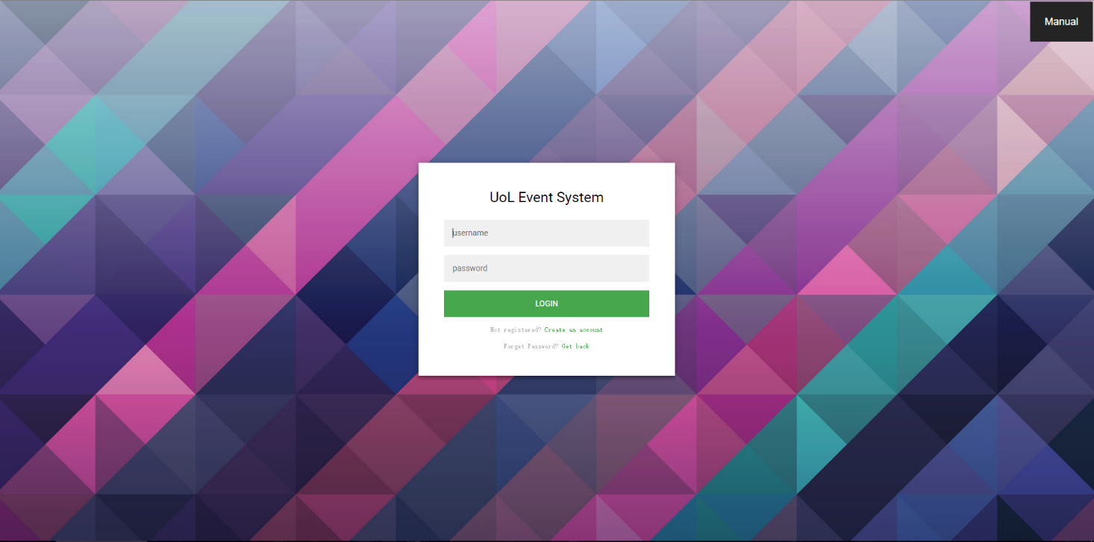User can enter the system after providing valid username and password. “Registration” and “Get back password” functions are also provided.

Figure 1 Login

1. Main interface of the system

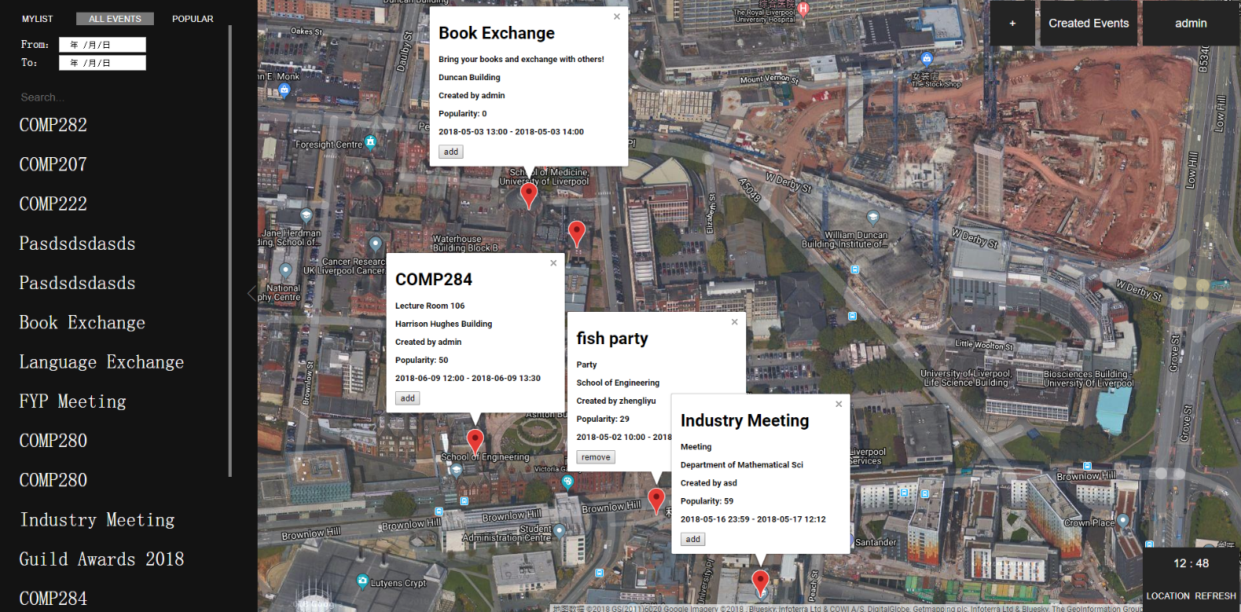The main interface of the system. Details of events can be shown on a map and users can find different functions by interacting with different parts of the interface.

Figure 2 Main Interface

1. New events creation

Events managers can use this window to create new events.

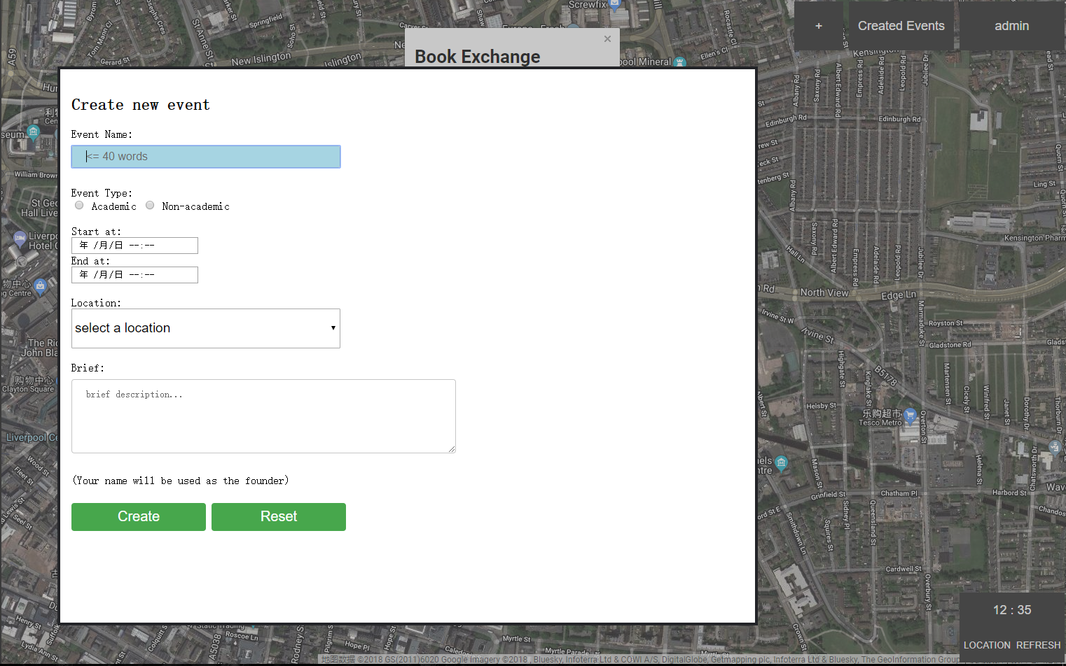

Figure 3 New Events Creation